

**COMSATS University Islamabad, Lahore Campus**

Defence Road, off Raiwind Road, Lahore

**Terminal Examination – FALL 2020**

|  |  |  |  |  |  |  |  |  |
| --- | --- | --- | --- | --- | --- | --- | --- | --- |
| Course Title: | Object Oriented Programming | | | | Course Code: | CSC241 | Credit Hours: | 4(3,1) |
| Course Instructor/s: | Dr. Allah Bux Sargano, Dr. Shahbaz Akhtar Abid, Mr. Bilal Arshad,  Mr. Asif Shahzad | | | | Program Name: | BSCS, BSSE | | |
| Semester: | 2nd, 3rd | Batch: | FA19, SP20 | Section: | A, B, C | Date: | January 18, 2021 | |
| **Time Allowed:** | **2 Hours, 20 Minutes** | | | | **Maximum Marks:** | | **80** | |
| Student's Name: |  | | | | Reg. No. | |  | |

**Important Instructions:**

1. Must write your name and registration number above, before starting your paper.
2. Set all code font size to 10px. It must be properly formatted.
3. After you are done, make PDF file of this word file. Rename the file to **YOUR REGISTRATION NUMBER – NAME.pdf** and upload in Google Classroom’s related assignment section.
4. Answer only what is asked, there are no additional marks of sharing information that is not asked. Similarly, in the code, additional implemented functionality, carry no additional marks.

## Question 1: [20 Marks]

1. What is the concept of binding? Differentiate between early binding and late binding. (Write in maximum 5 lines) [5 Marks]
2. Write a Java operator/keyword, which can be used to check the validity of reference before attempting down-casting from superclass object to subclass reference. Given an example of it usage. (Write in maximum 5 lines) [5 Marks]
3. Assume you have a method expecting the superclass's object to be passed as an argument. In this case, if you give it an object of subclass rather than superclass. Is it acceptable? Why or why not? (Write in maximum 5 lines) [5 Marks]
4. Which of the following assignments in FruitDriver class are valid or invalid. Give a reason for each.   
   [5 Marks]

class Fruit

{}

class Apple extends Fruit

{}

class Orange extends Fruit

{}

public class FruitDriver {

public static void main(String[] args) {

Fruit f= new Fruit();

Orange o= new Orange();

Apple a= new Apple();

o=f; //a

f=o; //b

a=o; //c

o=a; //d;

}}

**Answer**

## Question 2. [5+5=10 Marks]

What is fundamental difference/s between an abstract classes and interface (Write in maximum 5 lines).

Create an interface that shall have 2 methods and one string type attribute, also create an implementation class of the interface that shall define both methods (you can print YOUR favorite quote in each method body).

**Answer:**

## Question 3: [5+5+5 = 15 Marks]

Define *SemesterFreezException* and *InvalidCourseCodeException* as checked and runtime exceptions, respectively. The *SemesterFreezException* shall store *studentId* and the *InvalidCourseCodeException* shall store *courseCode* in corresponding instance variables*,* developer must pass these attributes when creating the exception objects. Override the *public String getMessage* in both classes, such that is shall return the data stored in the exception object.

**Answer**

## Question 4: [35 Marks]

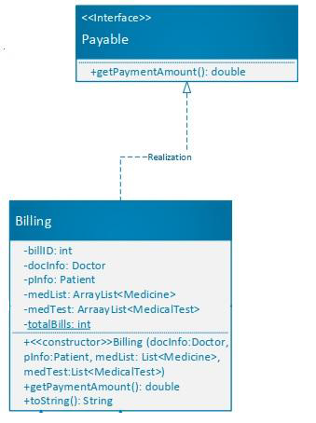

Consider the above scenario, where Billing class has composition relationship with Doctor having private instance variables (docName, docID and docFee) and a public getDocID() method, Patient having private instance variables (pName, pID, pDisease), Medicine having private instance variables (medID, medName, medQty, medPrice), and MedicalTest having private instance variables (testID, testName, testPrice). In addition, each class shall have toString method to display its object state. Also define getDocInfo method in Billing class that shall return the doctor. **[10 Marks]**. Implement getPaymentAmount() method in Billing class that shall return the total billing amount that includes doctor fee, medicine cost and medical tests fee. **[10 Marks]**

Considering the above scenario, write code that shall perform the following in the driver/test class:

1. Get an amount from user. Traverse the ArrayList<Billing> using enhanced for loop. Print the billing details of those bills having total billing amount greater or equal to the amount given by user. **[10 Marks]**
2. The program should create an ArrayList of Payable that holds two Billing objects. First Billing object comprised of two medicines and a medicalTest in addition to doctor and patient objects. The other billing object constitute three medicines and two medicalTest in addition to doctor and patient objects. **[5 Marks]**

**Answer**